Date: October 25, 2022
To: Weber County Board of County Commissioners
From: Ronna Tidwell
Community Development Department
Agenda Date: October 25, 2022
Subject: Request to Declare Parcel Number 11-340-0001 as Surplus Property
Attachments: A - Aerial Vicinity Map
B - Ownership Plat

_____________________________________________________________________________________

Summary:
A Weber County owned parcel of land, identified as Tax ID #11-340-0001, was acquired by the County through a tax sale process and deed executed in 2022. The parcel contains approximately .01 acres and is located at 1572 N 950 W, in Harrisville. See Attachment A for a vicinity map and Attachment B for the County Recorder’s ownership plat map.
The County has been contacted by an adjacent property owner who has asked if the County would consider selling the subject parcel.
Weber County has no intended use for this property; therefore, it is recommended that the parcel be declared as surplus and offered to the adjacent property owner. In order to convey real property, the County Commission must first take action to declare this parcel as surplus property.

Property Description:
11-340-0001
PART OF LOT 3R, HARRISVILLE HOLLOW PHASE 1, SUBDIVISION AMENDED LOTS 3R, 4R, AND 5R, HARRISVILLE CITY, WEBER COUNTY, UTAH, DESCRIBED AS BEGINNING AT THE NORTHEAST CORNER OF LOT 3R, THENCE NORTH 87D30'16" WEST 171.29 FEET, THENCE NORTHEASTERLY ALONG THE EAST SIDE OF 950 WEST STREET 8.5 FEET, MORE OR LESS, TO A POINT THAT IS NORTH 85D12'45" WEST 166.12 FEET FROM THE POINT OF BEGINNING, THENCE SOUTH 85D12'45" EAST TO POINT OF BEGINNING.
Attachment A

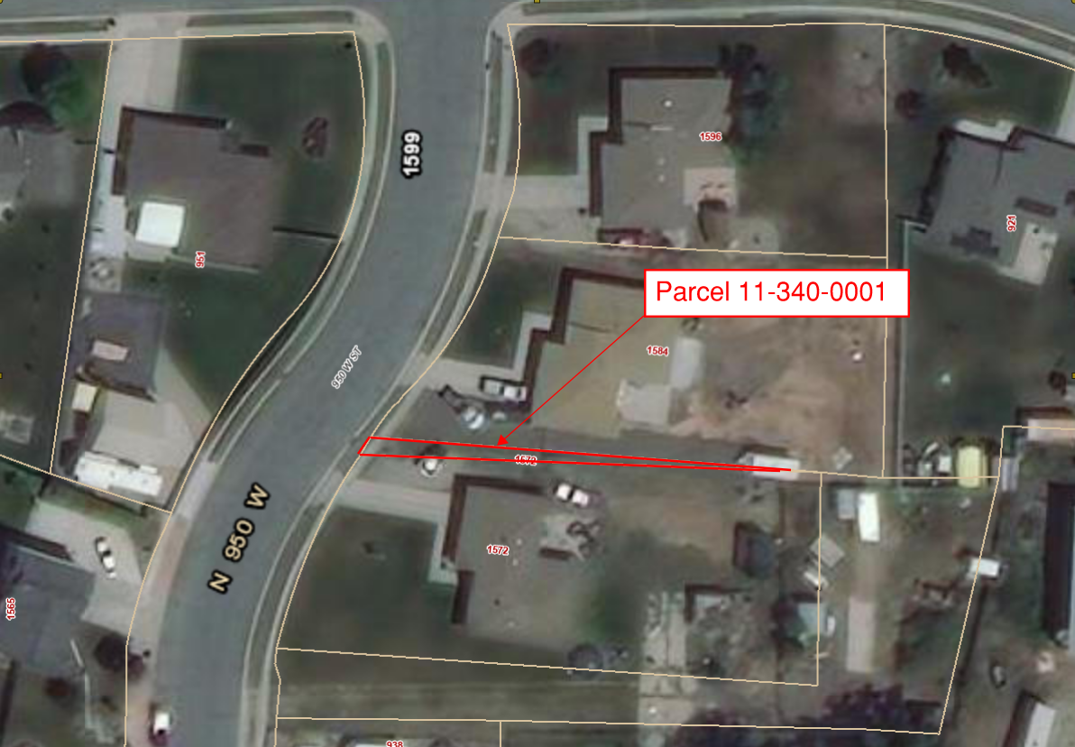

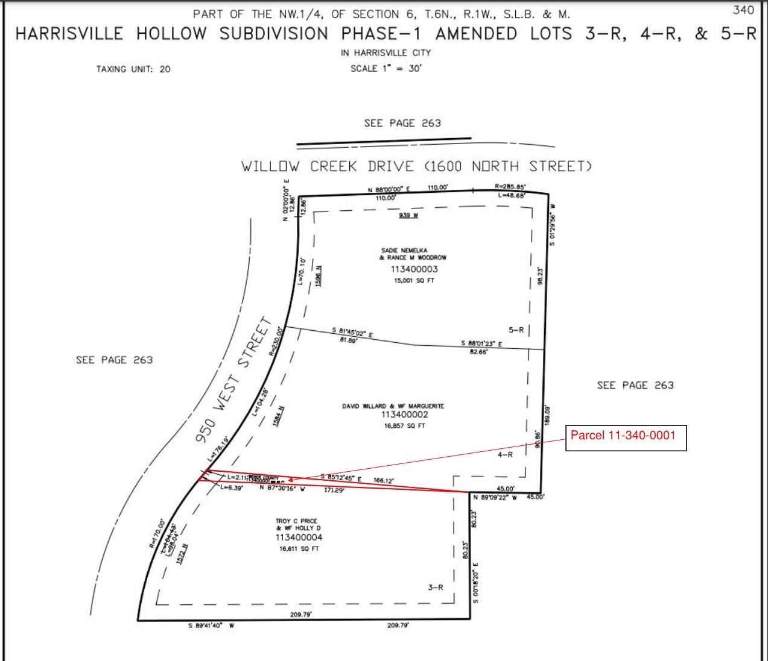
Attachment B

